**8.6 Maatschappelijke verantwoord ondernemen**

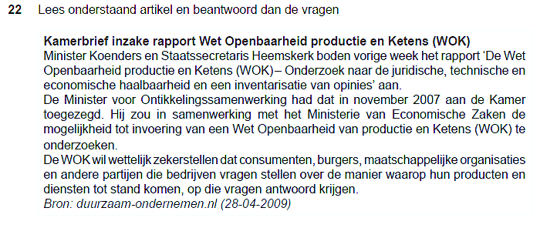



|  |  |
| --- | --- |
| A |  |
| B |  |
| C |  |

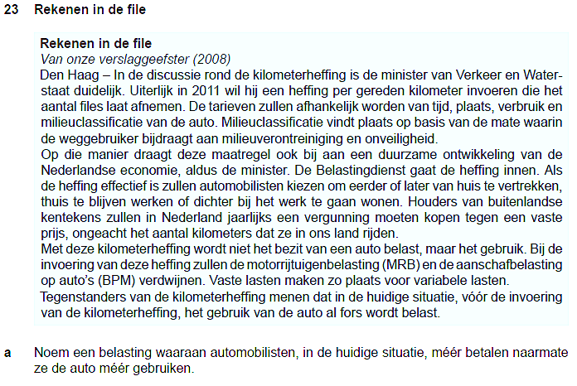

|  |  |
| --- | --- |
| A |  |





|  |  |
| --- | --- |
| B |  |



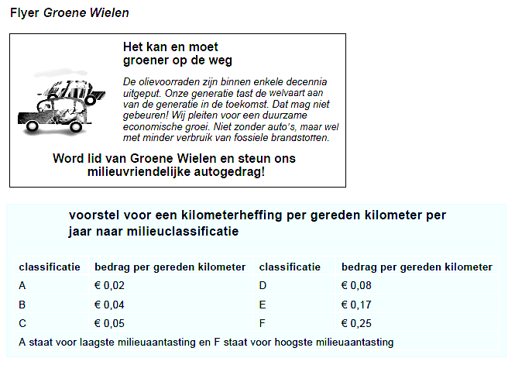

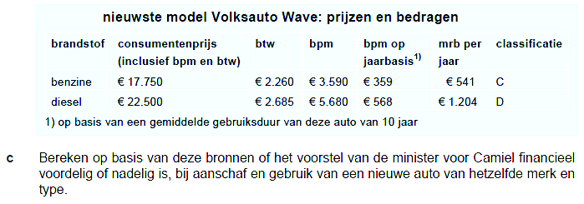

|  |  |
| --- | --- |
| C |  |



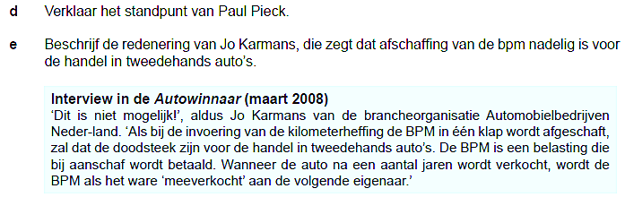

|  |  |
| --- | --- |
| D |  |
| E |  |

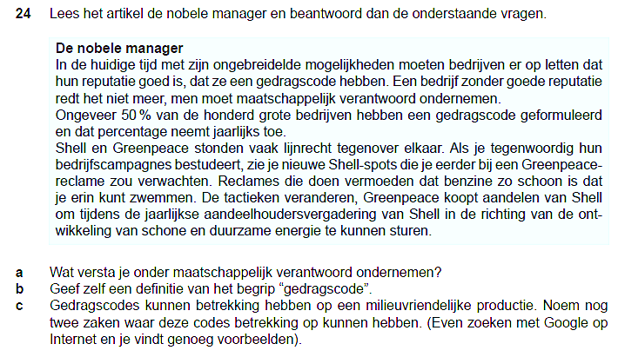

|  |  |
| --- | --- |
| A |  |
| B |  |
| C |  |



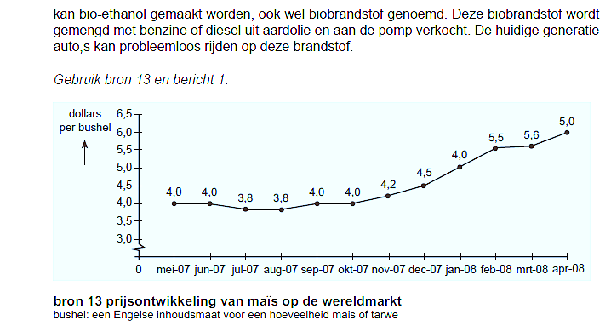

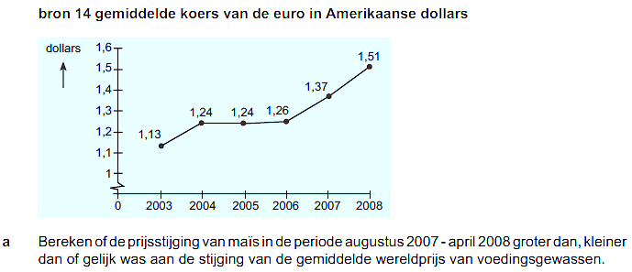

|  |  |
| --- | --- |
| A |  |





|  |  |
| --- | --- |
| B | A |
| B |
| C |
| D |
| E |
| F |