**Werkboek hoofdstuk 15 Goede tijden slechte tijden deel 2**

**Wat bedoelen economen met de conjunctuur?**

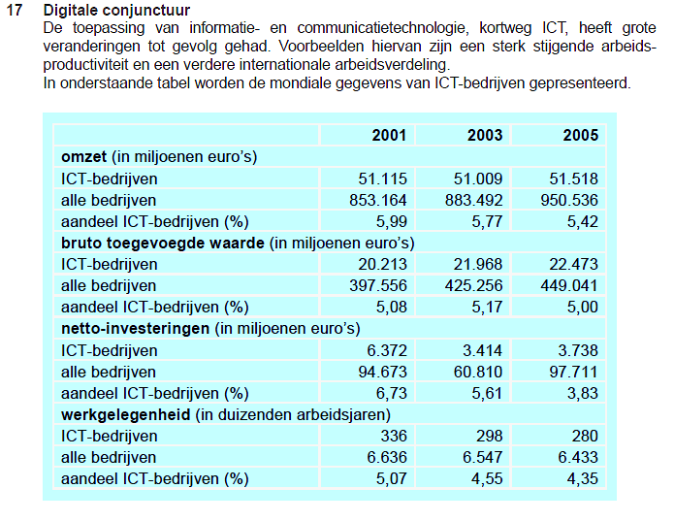





|  |  |
| --- | --- |
| **A** |  |
| **B** |  |
| **C** |  |
| **D** |  |



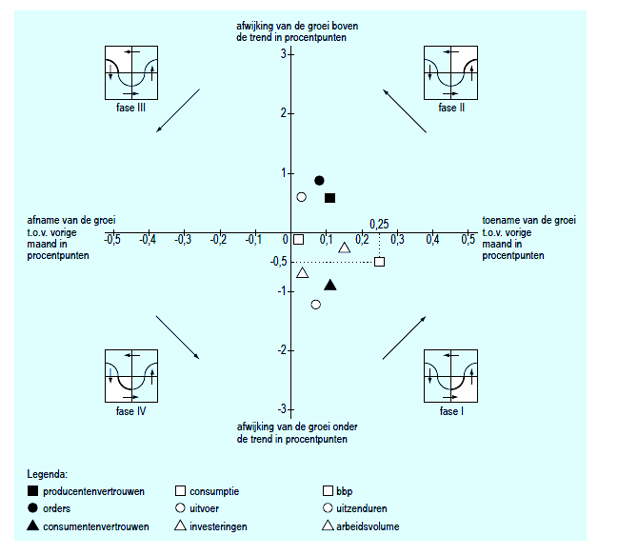





|  |  |
| --- | --- |
| **A** |  |
| **B** |  |
| **C** |  |
| **D** |  |

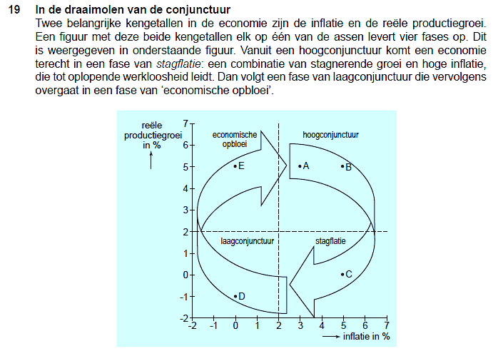



|  |  |
| --- | --- |
| **A** |  |
| **B** |  |
| **C** |  |
| **D** |  |
| **E** |  |



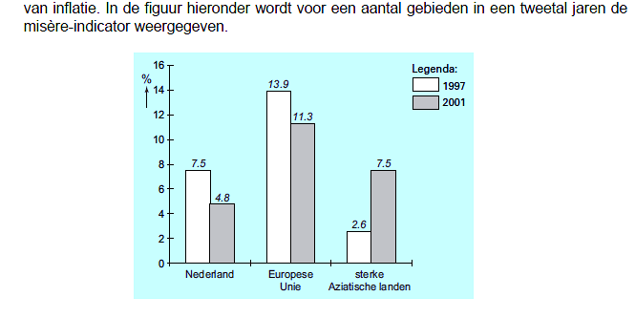



|  |  |
| --- | --- |
| **A** |  |
| **B** |  |
| **C** |  |
| **D** |  |

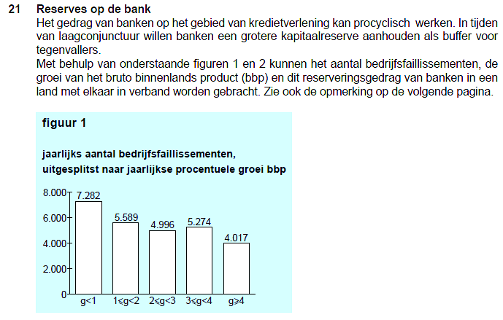

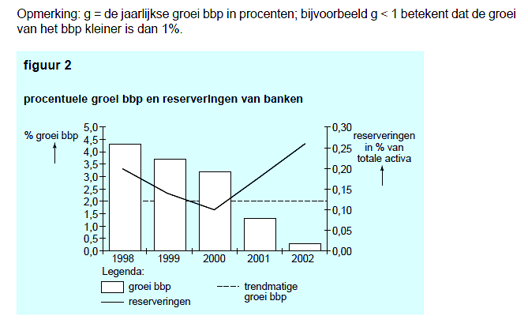



|  |  |
| --- | --- |
| **A** |  |
| **B** |  |
| **C** |  |
| **D** |  |

**15.7 Wat bepaalt de grootte van de productiecapaciteit?**

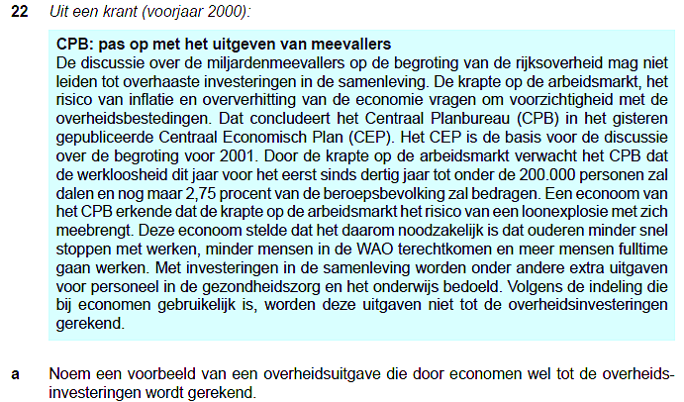



|  |  |
| --- | --- |
| A |  |
| B |  |
| C |  |
| D |  |



|  |  |
| --- | --- |
| A |  |
| B |  |
| C1 |  |
| C2 |  |
| C3 |  |



|  |  |
| --- | --- |
| D |  |
| E |  |
| F |  |