**9.4 Is onze sociale zekerheid ook een verzekering?**



|  |  |
| --- | --- |
| **A** |  |
| **B** |  |
| **C** |  |



|  |  |
| --- | --- |
| **A** |  |
| **B** |  |



|  |  |
| --- | --- |
| **A** |  |
| **B** |  |
| **C** |  |
| **D** |  |
| **E** |  |





|  |  |
| --- | --- |
| **A** |  |
| **B** |  |
| **C** |  |

**9.5 Op welke wijze financieren we de sociale zekerheid?**



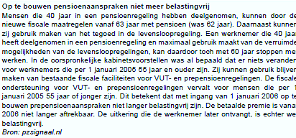



|  |  |
| --- | --- |
| **A** |  |
| **B** |  |
| **C** |  |

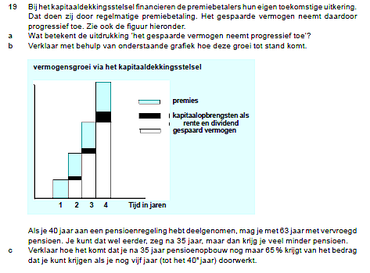

|  |  |
| --- | --- |
| **A** |  |
| **B** |  |
| **C** |  |



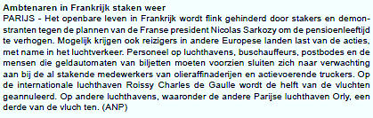

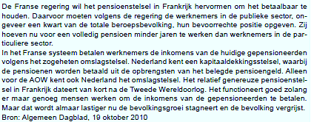



|  |  |
| --- | --- |
| **A** |  |
| **B** |  |



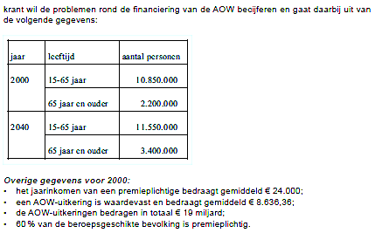



|  |  |
| --- | --- |
| **A** |  |
| **B** |  |
| **C** |  |
| **D** |  |



|  |
| --- |
|  |



|  |  |
| --- | --- |
| **A** |  |
| **B** |  |

**9.6 Wat maakt ons socialezekerheidsstelsel kwetsbaar?**



|  |  |
| --- | --- |
| **A** |  |
| **B** |  |
| **C** |  |
| **D** |  |

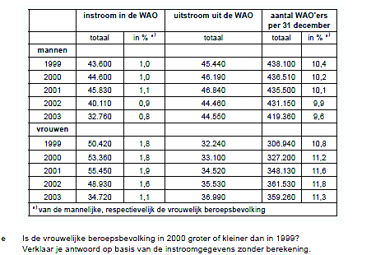

|  |  |
| --- | --- |
| **E** |  |



|  |  |
| --- | --- |
| **A** |  |
| **B** |  |
| **C** |  |
| **D** |  |



|  |  |
| --- | --- |
| **A** |  |
| **B** |  |
| **C** |  |
| **D** |  |











|  |
| --- |
|  |

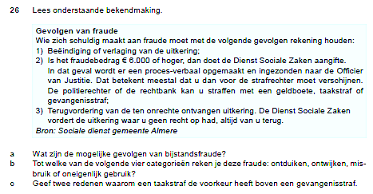

|  |  |
| --- | --- |
| **A** |  |
| **B** |  |
| **C** |  |

**9.7 Hoe tracht de overheid het draagvlak van de sociale zekerheid te versterken?**



|  |  |
| --- | --- |
| **A** |  |
| **B** |  |
| **C** |  |
| **D** |  |



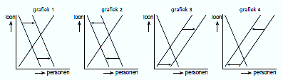



|  |  |
| --- | --- |
| **A** |  |
| **B** |  |
| **C** |  |





|  |  |
| --- | --- |
| **A** |  |
| **B** |  |
| **C** |  |





|  |
| --- |
|  |



